Wave Basics

Consider the diagram below in order to answer questions #1-2.

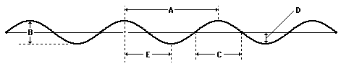

1. The wavelength of the wave in the diagram above is given by letter ______.

2. The amplitude of the wave in the diagram above is given by letter _____.

3. Is the wave shown above a transverse or longitudinal wave? ___________

4. A period of 5.0 seconds corresponds to a frequency of ________ Hertz.

5. As the frequency of a wave increases, the period of the wave increases, decreases or remains unchanged? ________________

6. A teacher attaches a slinky to the wall and begins introducing pulses with different amplitudes. Which of the two pulses (A or B) below will travel from the hand to the wall in the least amount of time? Justify your answer.

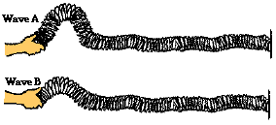

7. The teacher then begins introducing pulses with a different wavelength. Which of the two pulses (C or D) will travel from the hand to the wall in the least amount of time ? Justify your answer.

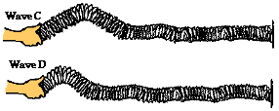

8. While hiking through a canyon, Noah Formula lets out a scream. An echo (reflection of the scream off a nearby canyon wall) is heard 0.82 seconds after the scream. The speed of the sound wave in air is 342 m/s. Calculate the distance from Noah to the nearby canyon wall. A picture will greatly improve your chances of success!

9. 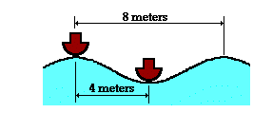Two boats are anchored 4 meters apart. They bob up and down, returning to the same up position every 3 seconds. When one is up the other is down. There are never any wave crests between the boats. Calculate the speed of the waves.

10. Ocean waves are observed to travel along the water surface during a developing storm. A Coast Guard weather station observes that there is a vertical distance from high point to low point of 4.6 meters and a horizontal distance of 8.6 meters between adjacent crests. The waves splash into the station once every 6.2 seconds. Determine the frequency and the speed of these waves.

11. Changing the amplitude will _______ the speed of the wave.

a) increase b) decrease c) not affect

12. Changing the freqiuency will _______ the speed of the wave.

a) increase b) decrease c) not affect